
IFMA Board Agenda- August 16, 2022
Invited via ZOOM: Priscilla StJG, Julie McK, Amber G, Amber K, Lauren L, Doug A, Chris C, Kurt T, Shelley M, John S, Bruce W, Nancy H, et al
Agenda: Meeting 3 of new board year
3.1 Introduction: Julie - Board meetings will continue via ZOOM. Everyone should now have update on their calendar (Third Tuesday of the month, 8 am) and hopefully we will all connect smoothly.
2022-23 Board of Director updates have posted on the website:
Board - Log into profile in IFMA and add photo and it will automatically update on chapter website.
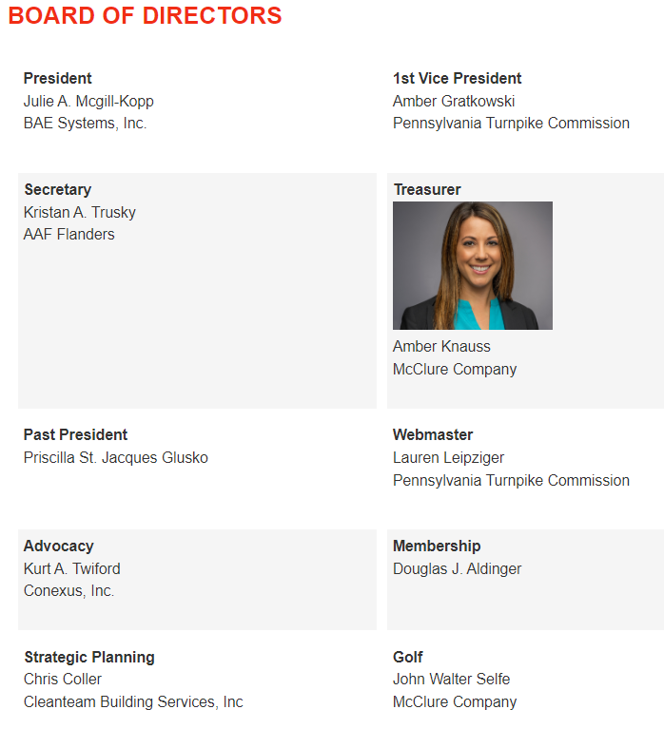
3.2 Star Chapter – who else should have or will needs access – discussion? Amber Gratkowski
3.3 Minutes discussion – April – June – July minutes need circulated and approved. Kristen reported some had been approved and will be uploaded via Lauren.
3.4 Reports and Old Business
VP Report: Amber G – No report
2nd VP Report: TBD
Secretary-Kristan-Discussed past minutes.
Treasurer Report- Amber K- Treasurer Report-
Amber shared monthly report and review suggested annual Budget and note the suggested changes to the board. Goal: Vote on annual budget after any discussion. Final budget to be circulated and approved by board along with August Minutes.
July Treasurer report was approved.
August-Golf outing – John and Amber provide board with update on success of the event. Share flyer with Photos of our scholarship recipients.
Strategic Planning: Chris – No report Priscilla will circle back with Chris and acquire updates.
3.5 Committees
Membership- Doug A – Julie will work with Doug - put on calender suggested months for coffee chats / breakfast,
Scholarship / Future FM - Bruce W - Shelly discussion – tapping into Penn state – YCAL
Priscilla – how to get local applicants – Bruce and P SG will work on this
And we will try to award to local if we are able to navigate that this year – foundation will be our option if we cannot get in front of local students or modify qualifications.
Shelly – will support as well and provide insight into partnership for career development – none of students can meet criteria
Look at the critiria for local scholarship – and make adjustments
Julie will share YCAL information at a future meeting.
Government- Julie will reach out to Kurt T work and T Koon to develop a program or Day on the Hill.
September 14 in a virtual Advocacy Day event sign up on IFMA national website.
Education/Certifications- Amber G – Not this month -
Web- Lauren L continues to post updates and is working the Sustainability Sept event at the Turnpike
3.6 New business: Board members met August 10 to develop suggested plan of events for the year
3.6A Julie to develop “Welcome Message” ASAP for Lauren to post with event three Month Look Ahead
3.6B Lauren is scheduling a meeting to review streamlining committees and event planning cont. Julie and Lauren will connect on this at World Workplace.
3.6C Three month look ahead – Fall Events
Month 1 –
Sustainable September – Turnpike - Green Gov Council event
Champion Lauren
World Workplace Nashville – connect while their maybe during day at conference – hard to make reservations.
Month 2 - October - Tentative 20th – Lets do the IFMA Two Step – A little bit of Nashville in Pa –
Step One – get members involved in Chapter, Step Two – Invite Prospective Members
Champion: Julie McGill-Kopp
Networking Hour 5 PM – to 7:30 PM
Tentative Location: Susq RiverCrossing Columbia Bourough
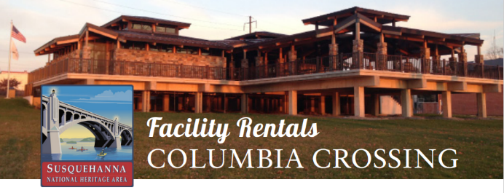
Rent Columbia Crossing for Your Next Event! (susqnha.org)
Julie to acquire required Insurance.
Objective: Step Insurance/ Liability All individuals renting Columbia Crossing facilities/equipment for weddings, receptions, or any events in which alcohol will be served and consumed shall obtain a certificate of liability insurance naming, in addition to the renter, Columbia Borough and Susquehanna NHA with minimum coverage of $500,000 bodily injury and $500,000 property damage.

Get someone to teach line dance and lasso
Share events from Nashville and Scholarship recipient and photos
Month 3 – November – Tentative 16th ? - Johnson Controls tour in Shrewsbury PA
Champion Doug Aldinger, Priscilla and FM Joe Emrich
3.6D For September Board meeting - Julie will formulate the additional events and activities discussed and get them out to everyone for review before next board meeting. Then we can assign champions to develop and solicit help from other chapter members.
Tentative Ideas:
Next Three Winter months:
December – Holiday and Community service event
January – February Virtual meetings?
Next Three Spring Months:
March – Day on the Hill Kurt and Tom develop together?
April – Local Tour also - Facility Fusion 2023 on April 11-13 in San Francisco, CA
May - Beaver Stadium again Lauren is checking into this – Board of Directors Voting
Next Three Summer Months:
June – Annual Meeting /? Tour
July – Local Baseball Game – Location TBD
August – Golf Tournament - Scholarship

3.6 E Possible Tours:
- UGI
- Four Seasons
- JLG
- Poultry Business
- Repeat Members First
- Beaver Stadium
- Lancaster – new hospital
- Others Members may be interested in?

Next scheduled Board Meeting: Tuesday, Sept 20 @ 8 AM
Note:
Advocacy Day – Virtual event Sept 14 – 11 AM to 1 PM
World Workplace Sept 28 – Sept 30 Nashville Tenn.

